**Ideation Phase**

**Define the Problem Statements**

|  |  |
| --- | --- |
| **Date** | 19 September 2022 |
| **Team ID** | PNT2022TMID17080 |
| **Project Name** | Signs with Smart Connectivity for Better Road Safety |
| **Maximum Marks** | 2 Marks |

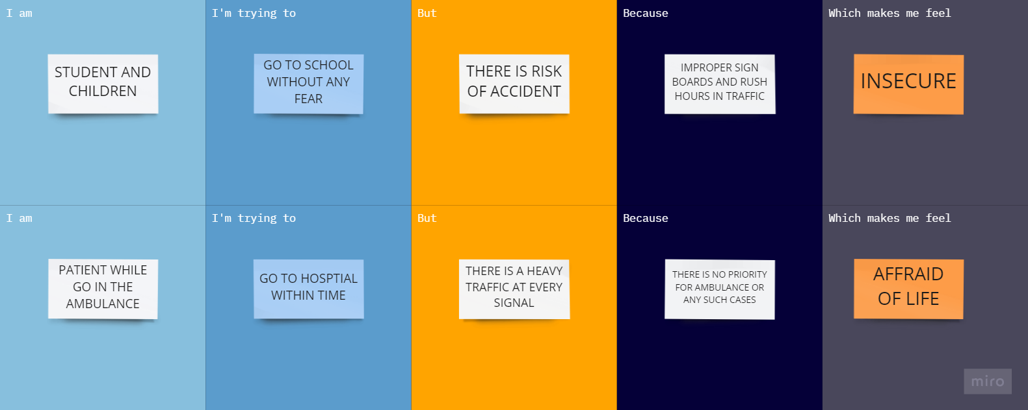

|  |  |  |  |  |  |
| --- | --- | --- | --- | --- | --- |
| **Problem Statement (PS)** | **I am (Customer)** | **I’m trying to** | **But** | **Because** | **Which makes me feel** |
| PS-1 | Student  or  Children | Go to school without any fear | There is risk of accident | Improper sign boards and rush hours in traffic | Insecure |
| PS-2 | Patient in ambulance | Go to hospital within time | There is heavy traffic at every signal | There is no priority for ambulance or any such cases | Afraid of my life |